Dishes | 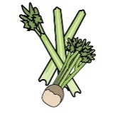 |  | 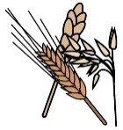 |  | 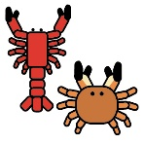 |  | 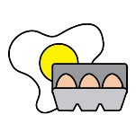 | 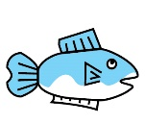 | 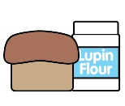 |  |  |  |  | 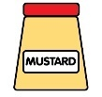 |  | 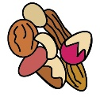 |  | 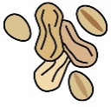 | 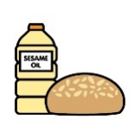 |  | 
 | Celery |  | Cereals containing gluten* |  | Crustaceans |  | Eggs | Fish | Lupin |  | Milk |  | Mollusc | Mustard |  | Nuts† |  | Peanuts | Sesame seeds | Soya | Sulphur Dioxide
House salad |  |  |  |  |  |  |  |  |  |  |  |  |  |  |  |  |  |  |  |  | ✓
Green beans
Mac ‘n’ cheese |  |  | ✓ |  |  |  |  |  |  |  | ✓
Triple cooked chips |  |  | ✓
Mash potato |  |  |  |  |  |  | ✓ |  |  |  | ✓
Skin on fires |  |  | ✓
peppercorn | ✓ |  |  |  |  |  |  |  |  |  | ✓ |  |  |  |  |  |  |  |  |  | ✓
gravy | ✓ |  |  |  |  |  |  |  |  |  | ✓
Review date:13/02/24 |  |  |  | Reviewed by: |  | Harvey Davies – Head chef |  |  |  |  |  |  |  |  |  |  | You can find this template, including more information at www.food.gov.uk/allergy-guidance

