Dishes | 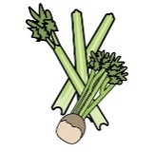 |  | 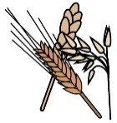 |  | 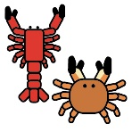 |  | 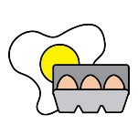 |  | 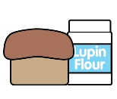 |  | 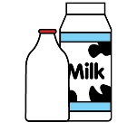 |  |  | 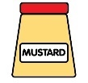 |  | 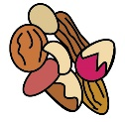 |  | 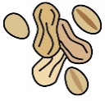 | 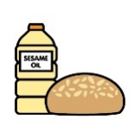 |  | 
 | Celery |  | Cereals containing gluten* |  | Crustaceans |  | Eggs | Fish | Lupin |  | Milk |  | Mollusc | Mustard |  | Nuts† |  | Peanuts | Sesame seeds | Soya | Sulphur Dioxide
Creamed wild mushroom tart |  |  | ✓ |  |  |  |  |  |  |  | ✓
Salt baked celeriac | ✓ |  |  |  |  |  |  |  |  |  |  |  |  | ✓ |  |  |  |  |  |  | ✓
seabass | ✓ |  |  |  |  |  |  | ✓ |  |  | ✓ |  | ✓ |  |  |  |  |  |  |  | ✓
Pork cheeks | ✓ |  |  |  |  |  |  |  |  |  | ✓ |  |  |  |  |  |  |  |  |  | ✓
chicken |  |  |  |  |  |  |  |  |  |  | ✓
Sirloin steak | ✓ |  |  |  |  |  |  |  |  |  | ✓ |  |  |  |  |  |  |  |  |  | ✓
Fillet steak | ✓ |  |  |  |  |  |  |  |  |  | ✓ |  |  |  |  |  |  |  |  |  | ✓
Review date: 13/02/2024 |  |  |  | Reviewed by: |  | Harvey Davies – Head Chef |  |  |  |  |  |  |  |  |  |  | You can find this template, including more information at www.food.gov.uk/allergy-guidance

